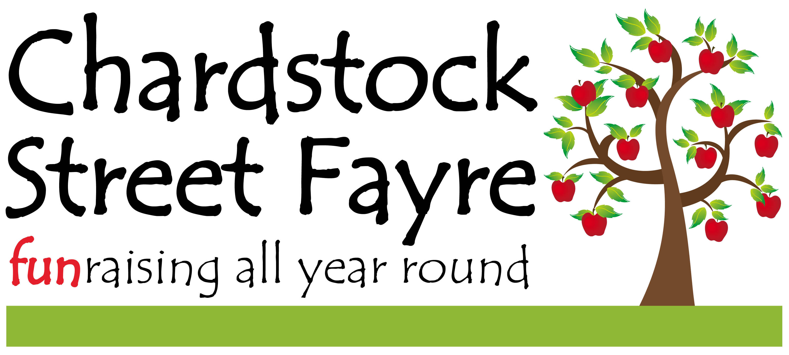
20th ANNIVERSARY FAYRE Saturday September 7th 2019
11am – 4pm
11-4pm

Pitch Request Form Please return the completed form and payment by 31st May 2019 – any payments received before this date will be given a £3 discount for a standard/trade pitch. Early payment will ensure your stall and product details are included in the Street Fayre Programme for the day.

Contact Name
Business Name / Organisation
Tel. No/Mobile No
Email Address
Address
Post Code
PITCH DETAILS Stall products sold/activity – full details please
Pitch sizes vary depending on the village location. If you need a minimum 10ft x 10ft normal gazebo size please state this. You will be notified of your pitch location about 10 days before the Fayre.
Standard | £15 | QTY |  |  |  | SUB-TOTAL £
Trade | £20 | QTY |  |  |  | SUB-TOTAL £
Charity/Other | FOC | QTY |  | Charity No. |  | SUB-TOTAL £
Food/Drinks Vendors | Price on application |  |  | Please contact Sue Alexander on  01460 391407 |  | SUB-TOTAL £
Tables | £5 each | QTY |  |  |  | SUB-TOTAL £
Please make cheques payable to Chardstock Street Fayre – if required BACS payments to A/C 19832273 Sort Code 60-05-06 (the ref. must include CSF2019 and/or the stall name/description/your name). |  |  |  |  | TOTAL ENCLOSED £

Special requests:

Signed | Date
Completed form and payment to: Sue Alexander, Strongs, Chardstock, Devon EX13 7BN
Tel. 01460 391407 / 07799 840300 Email: lesjalex43@yahoo.com
Further forms are available on the Chardstock Street Fayre website and on Facebook.

